**TASK 3: VULNERABILITY SCAN ON MY PC**

This task was similar to the one in which we were expected to scan for open and closed ports.

I have used Nmap for scanning the vulnerabilities and my PC.

The screen shots are as follows:

1)

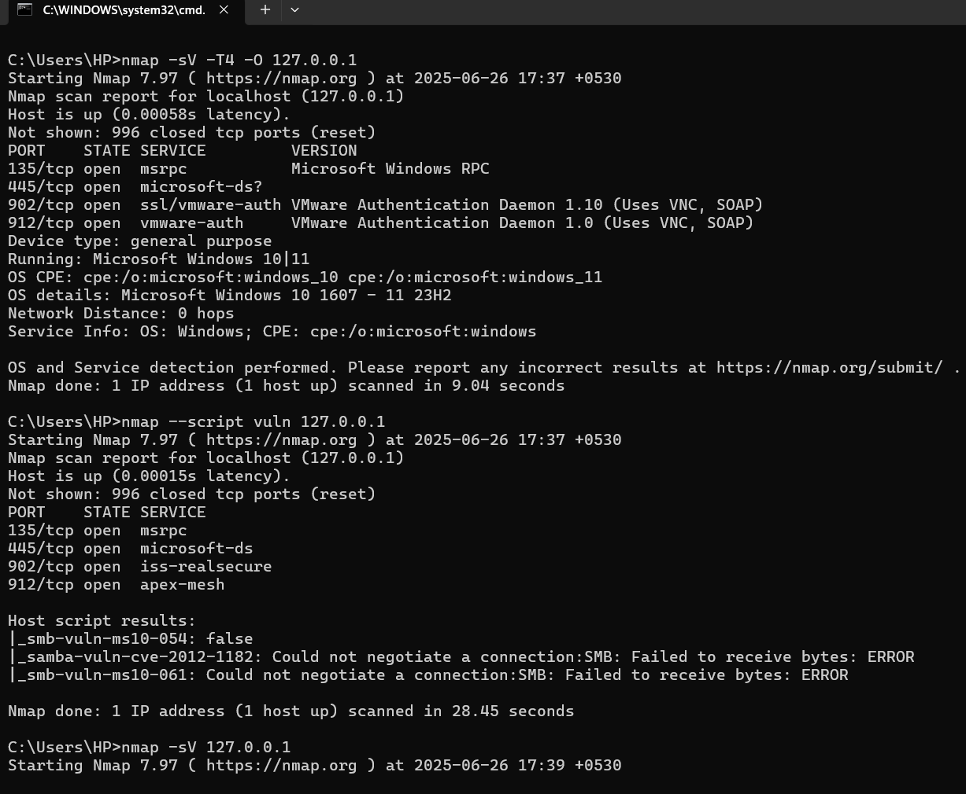

2)

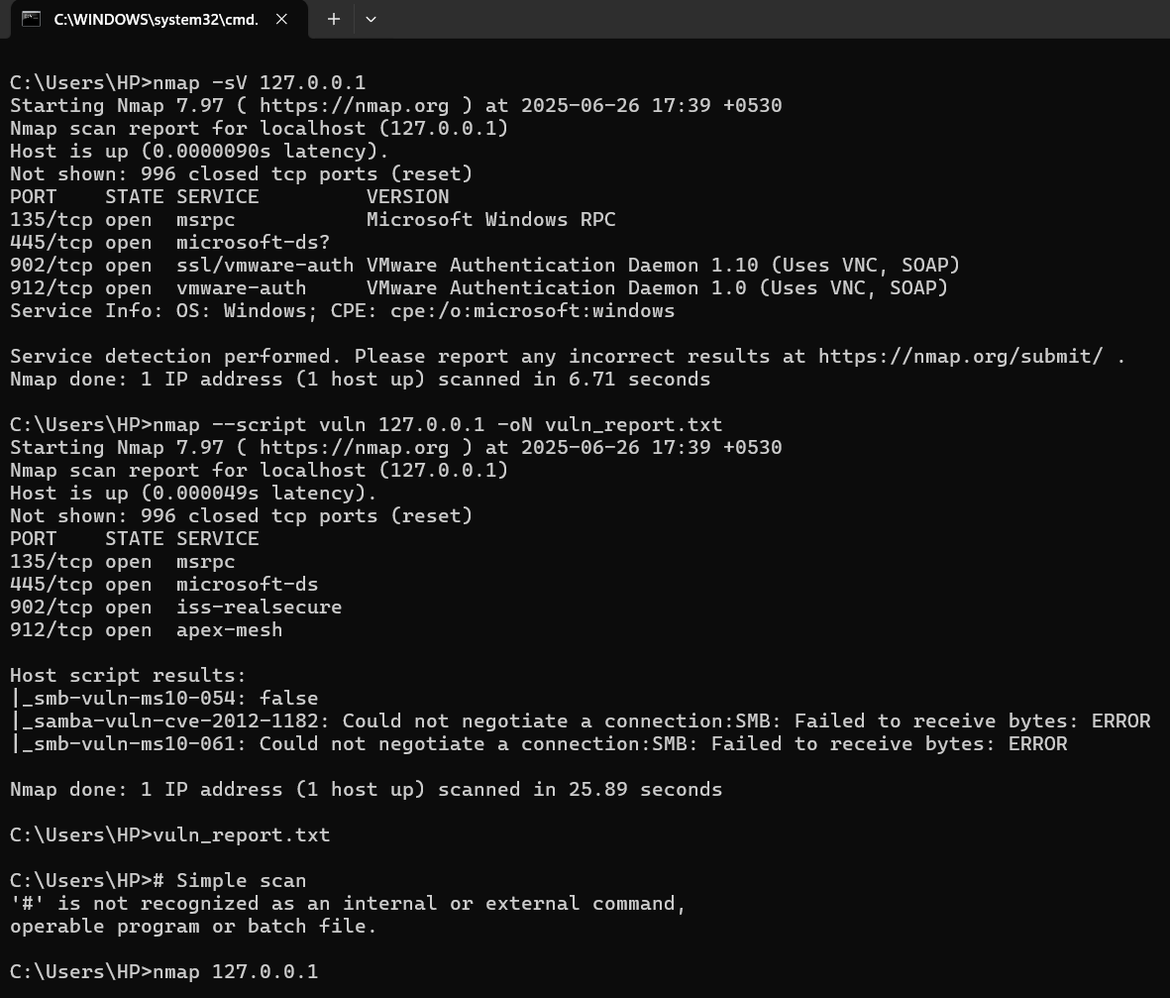

3)

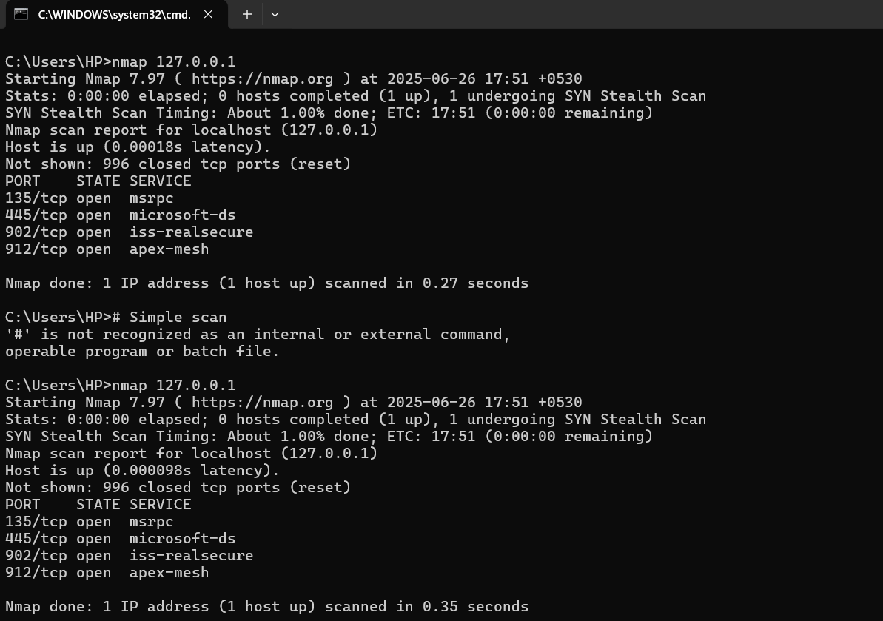

4)

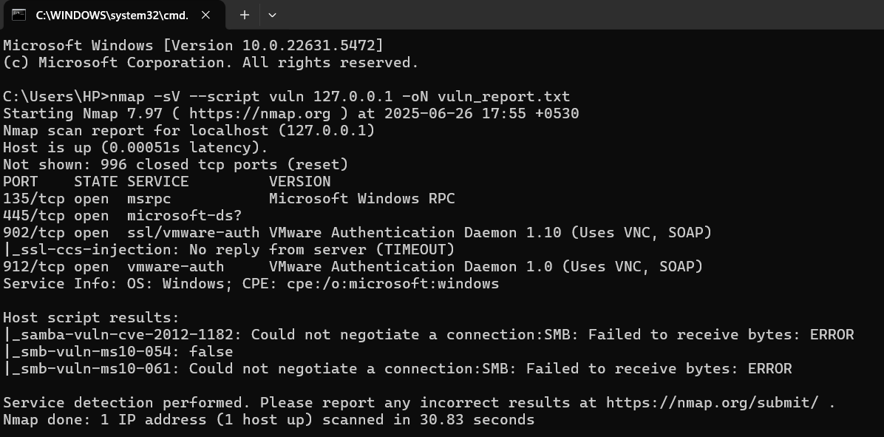

**SCAN REPORTS**

